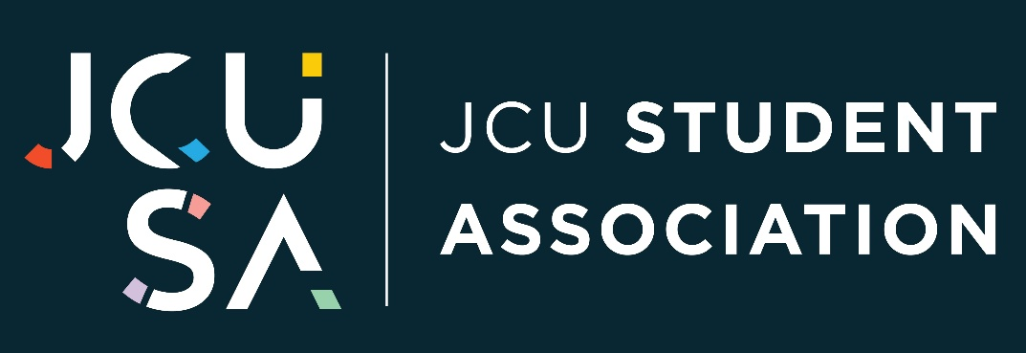

MINUTES OF THE 1st ORDINARY MEETING
56th STUDENT ASSOCIATION COUNCIL

Meeting: 56th Student Council – 1st Ordinary Meeting
Date: Friday, 5 December 2025
Time: 12:40 PM - 01:38 PM
Location: Online via. Microsoft Teams
Chair: Harrison O’Kane, JCUSA President
Secretary: Lu Zhang, JCUSA Secretary
Quorum: Confirmed (7 voting members present at start, new members joined later)

Attendance:
Voting Members Present:
- Harrison O’Kane (President)
- Lu Zhang (Secretary)
- Tsz Fei Zicilia Lo (Treasurer)
- Muhammad Islam (Vice-President) – joined at 12:46 PM
- Yanlong Yang (Cairns Campus Officer)
- Shiqi Zhu (Postgraduate Officer)
- Yandong Jiang (International Students Officer)s
- Nola Kuilboer (VC Nominee)* – joined at 12:55 PM
- Jeff Jimmieson (SPPL Staff Representative)*

Newly Appointed Voting Members During Meeting:
- Rhys Whitehurst (Townsville Campus Officer)
- Xi Zhuo (Women’s Officer)
- Wudarabin Snider (First Nations Officer)
- Yana Carpen (Environmental & Sustainability Officer)

Observers:
- Amanda Carter (SPPL Staff)
- Freddie Beldam (Nominee)
- Basil Sarguroh (Nominee)

* Note: For Motion 5.2.4 (Election of Environmental & Sustainability Officer), voting was restricted to student-elected representatives in accordance with Regulation 4.6.8. Jeff Jimmieson (SPPL Staff Representative) and Nola Kuilboer (VC Nominee) did not vote. Jeff Jimmieson fulfilled the role of Returning Officer for the secret ballot process in accordance with Regulation 4.7.

Acknowledgement of Country
“I would like to begin by acknowledging the Bindal and Wulgurukaba people of the Townsville region and Yirrganydji people of the Cairns region, the Traditional Custodians of the land on which we meet, study and work today, and pay my respects to their Elders, past, present, and emerging, and extend that respect to all Aboriginal and Torres Strait Islander peoples here today.”

1. Apologies and Proxies
- Apologies: None formally received
- Proxies: None

2. Declaration of Conflicts of Interest
- Nil declared

3. Confirmation of Previous Minutes
- No previous minutes or flying minutes to confirm

4. Reports – For Noting
- Reports included in Resource Pack. No verbal presentations requested

5. Matters for Decision
- Motion Register Table:

Motion No. | Title | Mover | Seconded | Outcome | Voting | Notes
5.1 | Update of JCUSA BOQ Bank Account Signatories | Harrison O’Kane | Tsz Fei Zicilia Lo | Carried | 6 In favour  7 voting members present
5.2.1 | Appointment of Townsville Campus Officer – Rhys Whitehurst | Harrison O’Kane | Jeff Jimmieson | Carried | Unanimous  8 voting members present
5.2.2 | Appointment of Women’s Officer – Xi Zhuo | Harrison O’Kane | Tsz Fei Zicilia Lo | Carried | Unanimous;  9 voting members present
5.2.3 | Appointment of First Nations Officer – Wudarabin Snider | Harrison O’Kane | Muhammad Islam | Carried | Unanimous;  9 voting members present
5.2.4 | Election & Appointment of Environmental & Sustainability Officer | Harrison O’Kane | Lu Zhang | Carried | Unanimous;  9 voting members present | Election via secret ballot. Returning Officer confirmed Yana Carpen as successful candidate
5.3 | Renewal of Membership with Student Voice Australasia | Harrison O’Kane | Lu Zhang | Carried | Unanimous;  9 voting members present | President to finalise renewal with assistance from SPPL

6. Action Items Table
Action | Responsible | Deadline | Status
Update BOQ Signatories | SPPL General Manager, JCUSA President, Vice President & Treasurer, Past Signatories | ASAP | Not started – cannot commence until all responsible persons are able to go to BOQ branch (currently some councilors are out of the country)  Likely to be complete Early February
Schedule induction for 56th Studdent Council | SPPL General Manager, JCUSA President | Before next Ordinary Meeting  Constitution requires induction within 4 months of election (March 2026 latest) | Not Started
New Councillors – Form Committees & Confirm Membership | JCUSA President, JCUSA Office Bearers | Early Trimester 1 | In Progress
Renew SVA Membership | JCUSA President, SPPL GM | December 2025 | Not Started

7. General Business
- Orientation Week planning: continue traditional events (Market Day, Pancake Breakfast), look to introduce new & more engaging events in future O-Weeks
- Feedback on Councilor Monthly Reports around requirements & details
8. Question Time
- Nil questions received
9. Close
- Time meeting closed: 1:38 PM
- Next meeting date: To Be Confirmed

Minutes confirmed by Lu Zhang
Secretary to JCUSA Council

