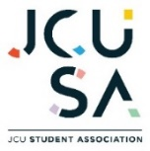Safe Food Handling Training is required by all staff, Councillors, volunteers and affiliated Clubs and Societies members who will be handling, preparing and/or cooking any food on behalf of the JCUSA.

Evidence of the completion of this training is to be provided to the General Manager prior to the first event/activity that involves food. For affiliated clubs and societies, failure to do so will result in not obtaining any grant/s from the JCUSA.

**Instructions on how to complete the training:**

Clink on this link – [LINK](https://www.imalert.com.au/foodsafety/training/welcome.php?sub=townsville)

**Step 1** – sign up as a New User

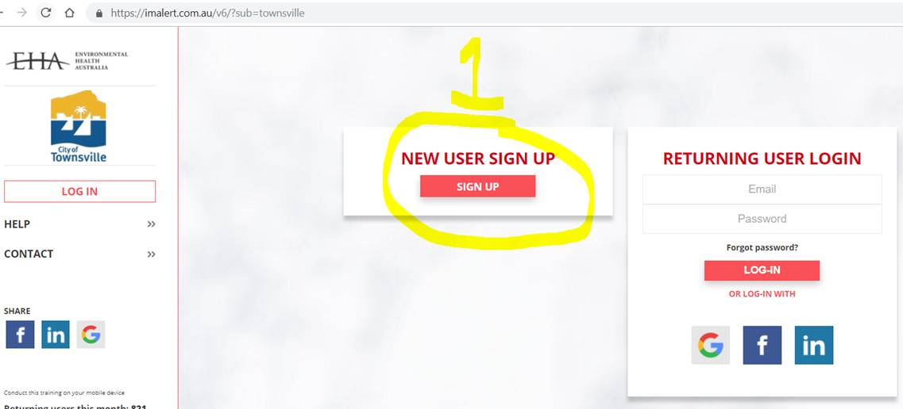

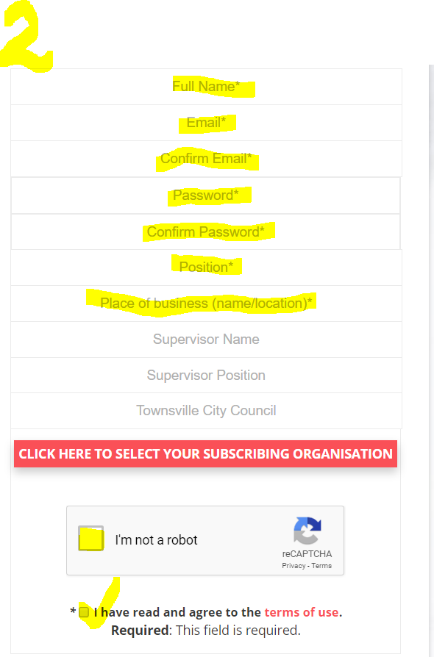

**Step 2** – fill in all of the fields except for where it states Townsville City Council – **leave this field** as is and submit.

Note – Supervisor name is Alison Edwards

Note – Supervisor Position is General Manager

**Step 3** – then go into the email account you just registered

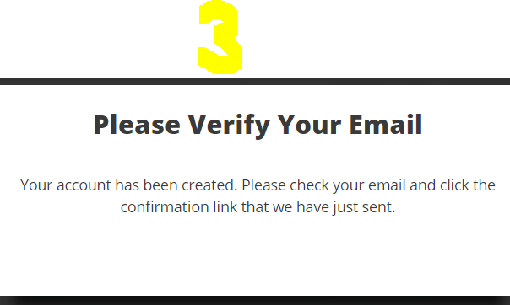

**Step 4** – Go to your email account and click on the link.  This will take you to the screen that you can then log into.

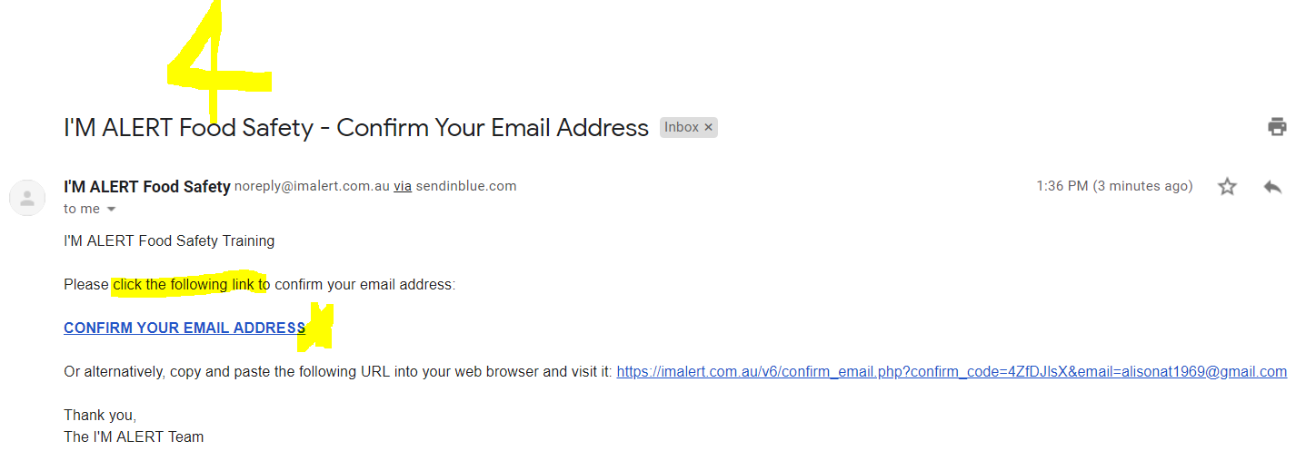

**Step 5** – enter your details in the Returning User Login

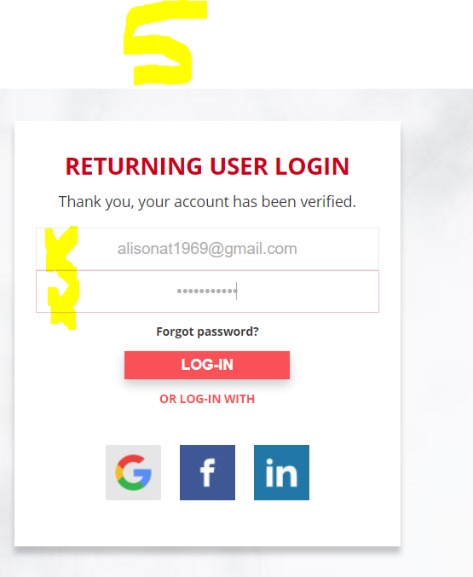

**Step 6** – You should now be in.    You now have a choice as we need **evidence** that you have completed the training required in policy – POL030 Safe Food Handling Policy

Either: 1 - You complete all subjects and email me through the certificate you should receive **or** only complete Foodborne Illness topics listed below and send me a snip it of the page that shows what topics you have covered.

1. Foodborne Illness;
2. Potentially Hazardous Food;
3. Contamination of Food;
4. Temperature Control;
5. Food Handling Skills and Knowledge;
6. Food Storage;
7. Health of Persons Who Handle Food;
8. Hygiene of Food Handlers; and
9. Cleanliness.

