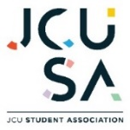
Safe Food Handling Training is required by all staff, Councillors, volunteers and affiliated Clubs and Societies members who will be handling, preparing and/or cooking any food on behalf of the JCUSA.

Evidence of the completion of this training is to be provided to the General Manager prior to the first event/activity that involves food. For affiliated clubs and societies, failure to do so will result in not obtaining any grant/s from the JCUSA and is a breach of the JCUSA WHS Risk Management Plan.

Instructions on how to complete the training:

Step 1 - Clink on this link – LINK

(If the link does not work, here is the website address http://dofoodsafely.health.vic.gov.au/index.php/en/)

You will see the below screen. You need to complete all of the topics and the assessment.

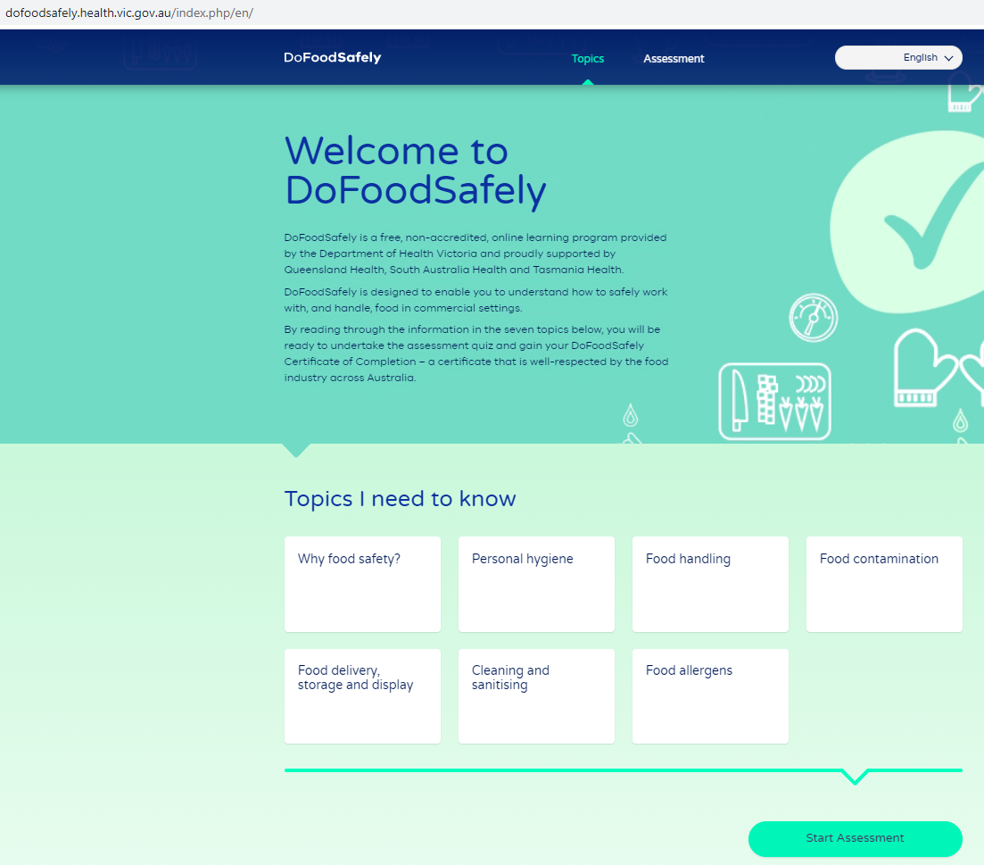

Step 2 – Complete the 7 fields above and answer the questions that are automatically generated throughout the subject.

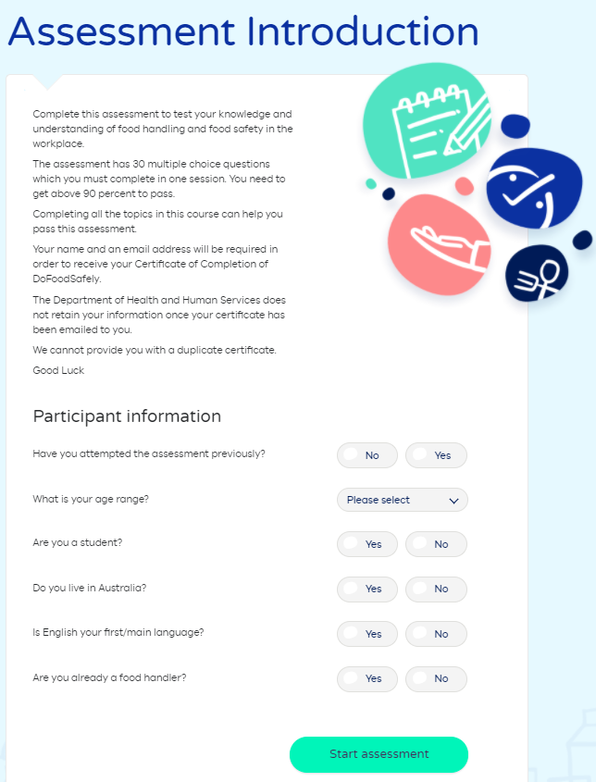
Step 3 – Click on the Start Assessment Button after completing all of the topics. This page will then come up.

Step 4 – Upon passing the assessment you will be required to provide your details, including an email address for delivery of your certificate.

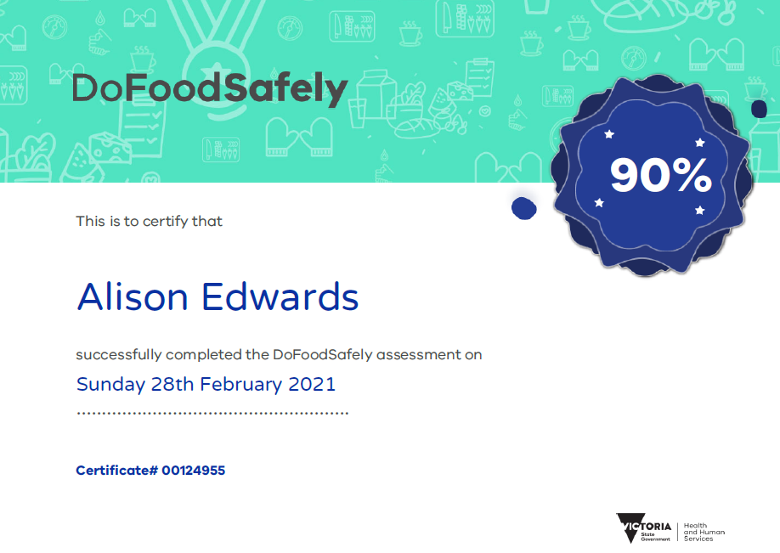
Step 5 – Upon receipt of your certificate, please email a copy to theresa.priddle@jcu.edu.au so it can be added to the training database.

Sample of the certificate that is to be provided.

