Clubs and Societies Sexual Misconduct Risk Assessment Form

Club/Society holding the event:
Name of event:
Date/s of event:
Time/s of event:
Brief explanation of event and the cohort that will be attending, eg, students only
How many people are expected to attend?
Where is the event being held?
Details of person completing this risk assessment: | Name:
I agree to read the following about consent before or at the start of the event: Yes/No
Consent means the free and voluntary agreement to participate in an activity which may include an intimate or sexual relationship given by a person with the cognitive capacity to do so.

Consent is not freely and voluntarily given if the person is:
- Under force;
- Unconscious or asleep;
- Under the influence of drugs or alcohol;
- Under threat or intimidation;
- ​In fear of bodily harm;
- Subjected to the exercise of authority;
- Under false or fraudulent representations about the nature or purpose of the act, or
- Under a mistaken belief that the offender was someone else (for example, their sexual partner).
Responsible Executive(s) for Incidents to be Reported to:
Mobile no: |  | Date form completed:
Instructions:
Note: Generic risks are provided in this template, however the list is not exhaustive and should be added to or modified to identify the specific risks relevant to your particular event, as necessary.
For each risk, the likelihood and consequence should be determined as per the matrix below. The overall risk ranking is then determined to help prioritise risks and subsequent controls/actions.
Email this completed form to:
Townsville: clubsandsocieties.tsv@lists.jcu.edu.au
Cairns: clubsandsocieties.cns@lists.jcu.eu.au

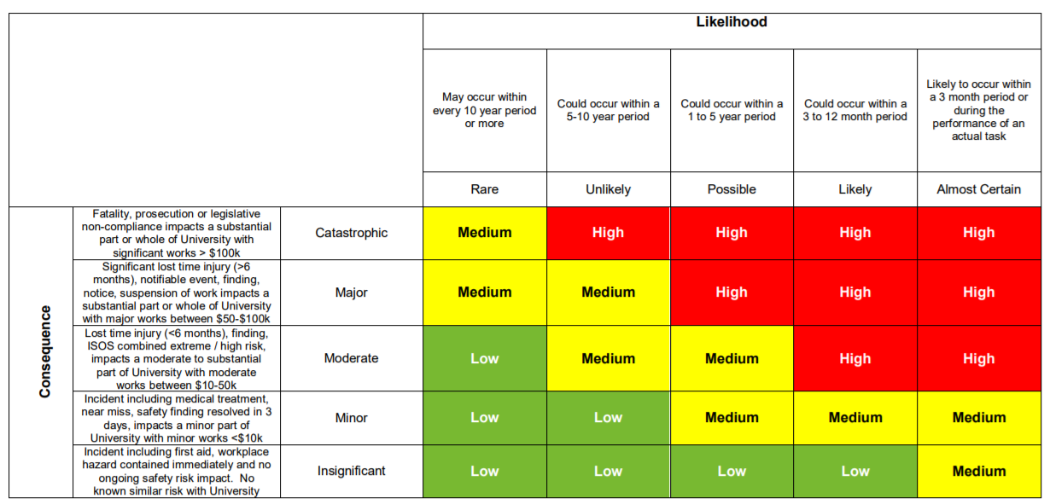
Legend
H = High Risk – Council attention needed
M = Moderate risk – management responsibility must be specified
L = Low risk – manage by routine procedures

Risk | Likelihood | Consequence | Ranking | Existing Controls | Treatment Plans | Responsible Officer
That JCU students are not aware of the university’s position on addressing/ managing/responding to sexual misconduct, sexual harassment and sexual assault. | Unlikely | Minor | Low | - Mandatory JCU Respect  - JCU Respect Now Always, Training, Workshops and Events  - JCU website https://www.jcu.edu.au/safety-and-wellbeing/jcu-respect-now-always-training-workshops-and-events | - JCU Respect workshops provides students information about respectful relationships, bystander behaviour and the prevention of, and how to respond to sexual harassment and sexual assault  - JCU has a comprehensive suite of initiatives student communities designed to prevent and respond to sexual harassment and sexual assault.  - JCU Website  - JCU Respect Now Always, Training, Workshops and Events | - Club/Society Executive Committee Members  - JCU students
That JCU Students are not aware of the contents of the sexual misconduct, sexual harassment, sexual assault policies and procedures. | Unlikely | Minor | Low | - JCUSA Club/Society Bi Annual Induction Nights for Executives  - JCU mandatory online Respect training  - Club/Society Induction | - https://www.jcu.edu.au/safety-and-wellbeing/sexual-harassment-and-sexual-assault  - JCU Respect online module - is an online module addressing sexual harassment and sexual assault that all students and staff are required to complete. The module provides introductory content on recognising a problem (including basic consent/bystander behaviours), responding to disclosures by others, referring to appropriate support services, and reporting to the University and other agencies.  - Form 198 Clubs/Society Induction Checklist: Own Members  - POL048 Clubs and Societies Policy  - POL098 Clubs and Societies Induction Policy  - DOC007 Clubs and Societies Code of Conduct  - DOC019 Legislation  - Presentation at the bi-annual JUCSA Club/Society night by a JCU Respect facilitator  - JCU Respect Student Reference Group | - Club/Society Executive Committee Members  - JCU students
That JCU student do not know how to report incidents of sexual misconduct. | Unlikely | Minor | Low | - Club/Societies own Induction  - JCU Respect Mandatory Training  - JCU Website  - JCUSA Club/Society Bi Annual Induction Nights for Executives | - Access to JCU Sexual Misconduct Officers provide a single point of contact at JCU for a person who has been subject to Sexual Harassment or Sexual Assault, or to the manager or person supporting that person.  - https://www.jcu.edu.au/safety-and-wellbeing/sexual-harassment-and-sexual-assault/sexual-misconduct-officers  - Reporting an Incident of Sexual Misconduct to JCU  - Sexual Misconduct Officers  - You are able to make an anonymous report but the actions that are possible in response to anonymous reports are limited.  - Make a Report - JCU Australia  - Induction  - Training  - JCU Respect Training:  JCU Respect online module that provides introductory content on recognising a problem (including basic consent/bystander behaviours), responding to disclosures by others, referring to appropriate support services, and reporting to the University and other agencies. | - Club/Society Executive Committee Members  - JCU students
That JCU students have not completed mandatory training on training on sexual misconduct. | Unlikely | Minor | Low | - JCU Mandatory Training  - JCUSA Club/Society Bi Annual Induction Nights for Executives | - JCU Respectful Relationships Workshops - "Let’s Talk Respect” is the newest JCU Respect workshop that all students who have lived on campus for more than 1 year are required to do.  - JCU Respectful Relationships Workshops - Residential Students is a 2 hour practical, interactive workshop that is held across different sessions during O-Week and Week 1 and 2 of Study Period 1.  - JCU Respectful Relationships Workshops – Student Leaders  - JCU Respectful Relationships Workshops - HDR Candidates is a compulsory, practical, interactive workshop  - .JCU Respectful Relationships Workshops – Advisors | - Club/Society Executive Committee Members  - JCU students
That JCU students so not know how to respond to to occurrences of sexual misconduct. | Unlikely | Minor | Low | - Training  - JCU Security  - 000  - Bystander Training | - https://www.jcu.edu.au/safety-and-wellbeing/sexual-harassment-and-sexual-assault/make-a-report  - JCU Respect Training:  JCU Respect online module that provides introductory content on recognising a problem (including basic consent/bystander behaviours), responding to disclosures by others, referring to appropriate support services, and reporting to the University and other agencies.  - Access to Sexual Misconduct Officer  - Responding to Disclosures training (JCU staff only) | - Club/Society Executive Committee Members  - JCU students
- Alcohol  - Excessive or dangerous consumption of alcohol during the event  - Inappropriate behaviour after alcohol consumption, e.g. violence/aggression, sexual harassment  - Overcrowding outside venues  - Minors being served alcohol inside venues  - Drink spiking  - Lack of transport options for students during the event  - Students under the influence of illegal drugs  - Students attend event already under the influence of alcohol  - First aid provision  - Licensing  - Responsible Service of Alcohol  - Crowd Management  - Injury and/or property damage  - Unfamiliar with WHS policies and procedures  - Activities that adversely impact the Association and/or staff or JCU  - Slips, trips & falls injury management from spilt drinks  - Traffic accident/ hit by a vehicle  - Risks associated with an events theme  - Fire in a venue  - Event management  - Damage to reputation  - Financial Risk and costs | Unlikely | Minor | Low | - Application for Function Form (JCU) to be approved by JCU Security  - University Bar on site with own licensing & security  - Risk Assessment  - Event Application Form  - Licensed premises  - Public venues approved by council  - Not serving under aged people  - Responsible Service of Alcohol  - ABAC responsible alcohol marketing code  - Advertiser code of ethics adopted by the Australian Association of National Advertisers  - OLGRs Liquor Compliance Strategy  - JCU Student Code of Conduct Policy  - JCU Student General Misconduct Procedure  - JCU Bullying, Discrimination, Harassment and Sexual Misconduct policy  - JCU Sexual Harassment and Sexual Assault  - Policy POL091 Disaffiliation Policy  - DOC007 Code of Conduct  - Criminal Code Act 1899, SECT 316A Unlawful drink spiking  - Drugs Misuse Act 1986  - Building Fire Safety Regulation 2008  - Transport Operations (Road Use Management—Road Rules) Regulation 2009  - Defamation Act 2005  - Anti-Discrimination Act 1991  - Criminal Code Act 1899  - Liquor Act 1992  - Supervision  - Length of the event  - Accessibility  - Crowd mix  - Number of people attending | - JCU Security  - Privately arranged security personnel  - Application for Function Form (JCU)  - DOC007 Clubs and Societies Code of Conduct  - JCU Policies and procedures  - Licensed venues  - Use of buses to transport students to venues  - Public bus available to/from the campus  - Responsible person/s remaining sober  - First aid kit on hand  - Checking IDs for proof of age before attending the event  - Not dressing in a manner that is offensive or derogatory  - Access to food  - JCU Safe App – for on campus events | - Club/Society Executive Committee Members  - JCU students

Overall risks for events that have alcohol and other considerations

Criteria | Low Risk Event | Medium Risk Event | High Risk Event
Venue | On campus licensed | Off campus licensed | Other
Alcohol | Non-alcoholic beverages served, light beer only, no spirits | Non-alcoholic beverages served, full strength beer as well as light beer and wine | Full strength and light beer, wine, spirits and water
Food | Two/three course Meal served near start of event | Food (dips, cheese, crackers etc) available ½ hour before alcohol available | No food or only salty food (chips/nuts)
Supervision | Dedicated supervision | Part time supervision | No supervision
Length of event | < 2 hours | 2-4 hours | > 4 hours
Bar Staff | Trained paid staff | Combination of paid staff and volunteers (trained and untrained) | Self serve or volunteers (untrained), BYO
Bar Service | Cash (licensed) | Combination | Open / BYO
Type of Activity | Low key | Special occasion | Party (end of year, Pub Crawl)
Accessibility | Majority can walk, get taxis or use public transport | Majority must drive, taxis and public transport available | Everyone must drive, no public transport
Mobility of event | Event starts and finishes in one location | Events starts in one place then people are encouraged to move to another | Pub crawl type event, three or more locations
Crowd mix | > Number of females  Broad age mix | Females equal to males  People in 20’s-30’s > | Number of males  People in 18 – 25s
Number of people | < 50 | 50 -100 | > 100
Underage present | None | Limited number | 20+% of attendees

